CA WHEEL STUD CONVERSION FITTING GUIDE
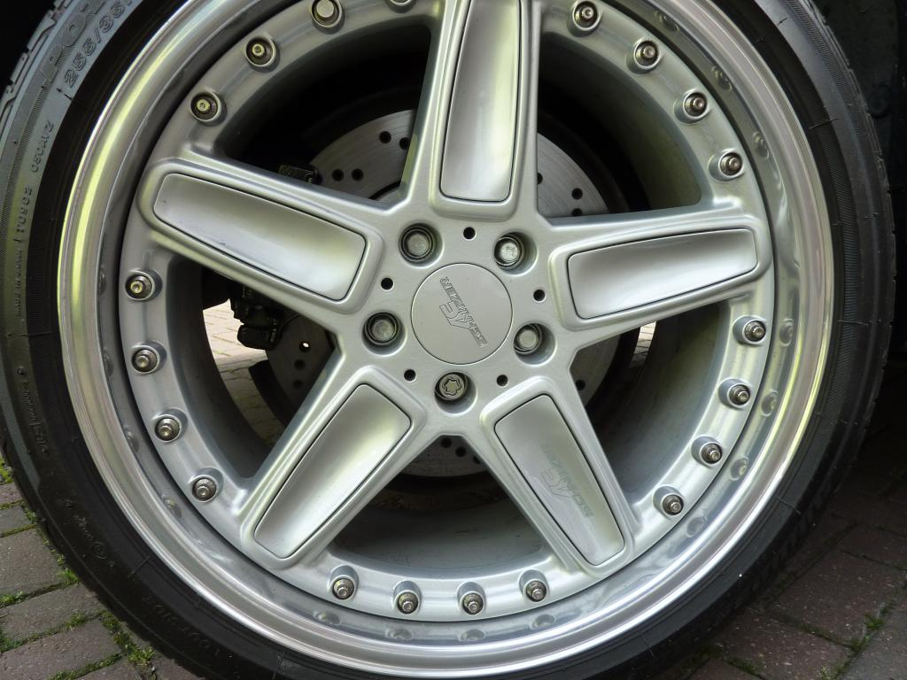
BEFORE
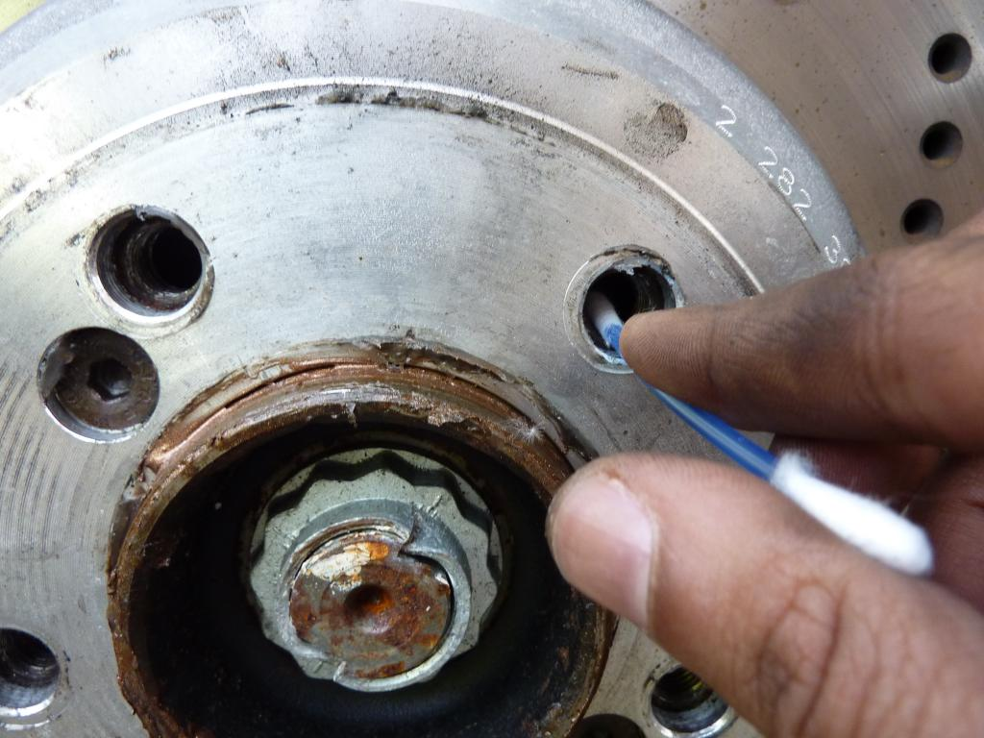
REMOVE WHEELS AND CLEAN THREADS TO REMOVE ANY DIRT TRAPPED
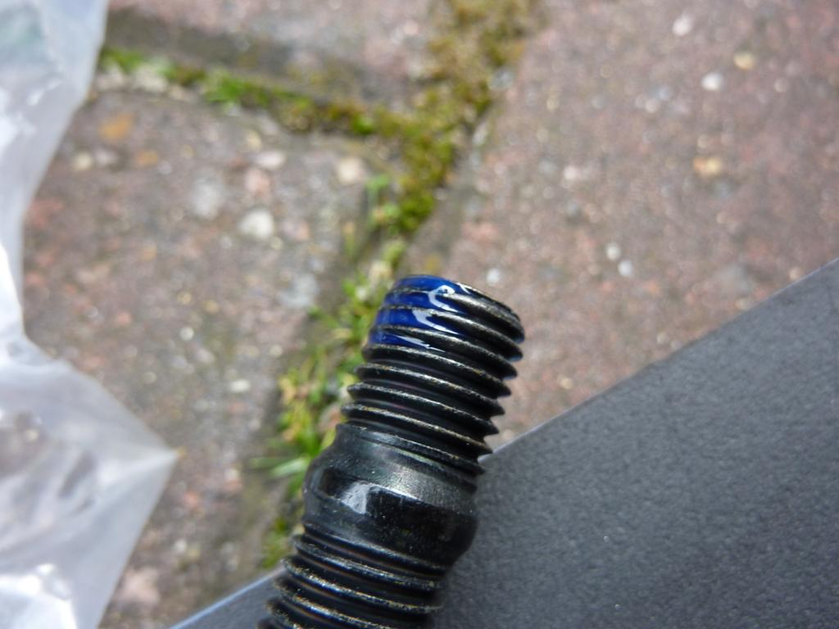
APPLY A DROP LOCTITE TO THE SMALL THREADED END OF THE STUD
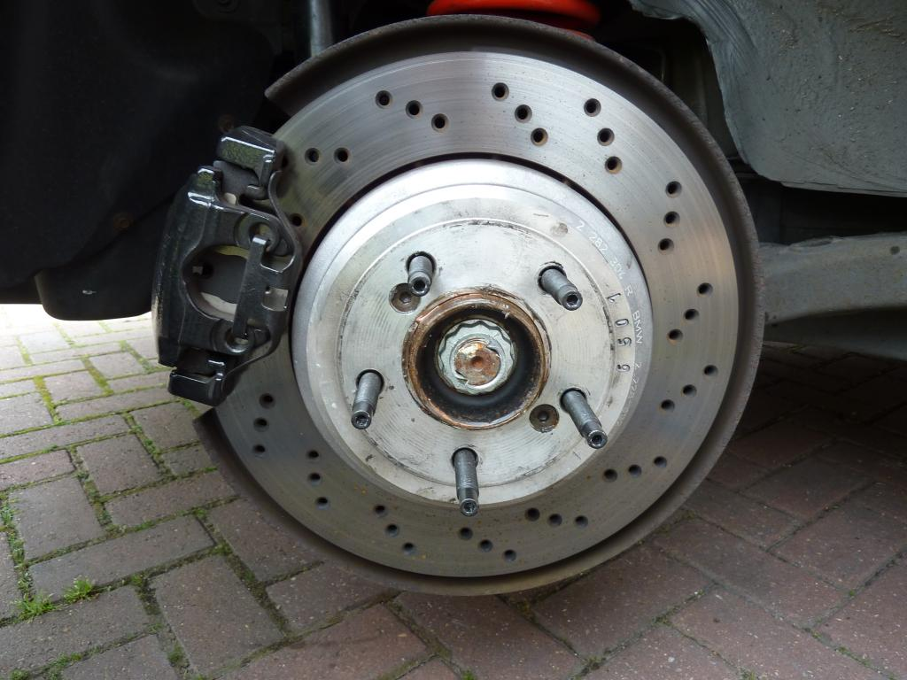
TIGHTEN THEM ALL UP IN THE HUB
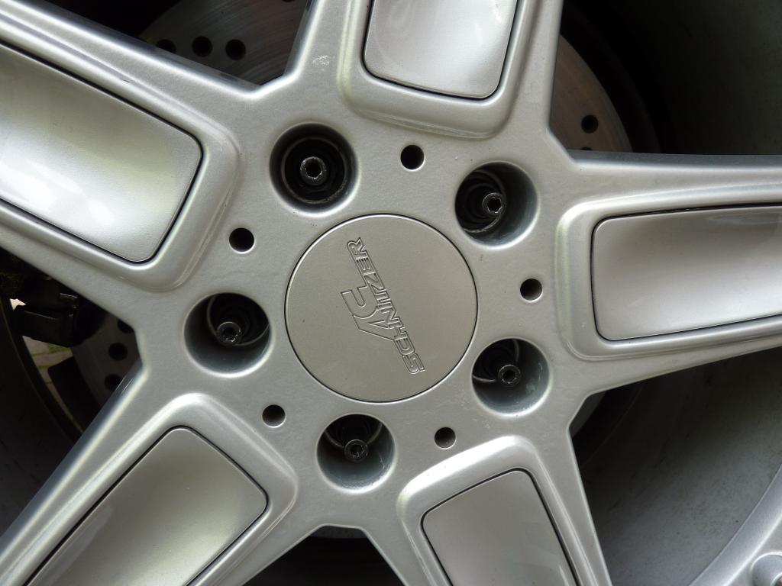
WHEEL FITTED BACK AND STUDS TIGHTEN AND THE JOB IS FINISHED.

